

Welcome!
March 30th, 2025
Our Services:
Sunday: 9:45, 10:45, 5:00
Wednesday: 7:00
Sermon:
Colossians 3:8
“Put off all these…”
Announcements:
*Trinity Kids: April - Brian
*JOY – Thank you for all who came out! We have 200 hanging bags to pass out! Get ready! Thank you, Sarah, for the great food!
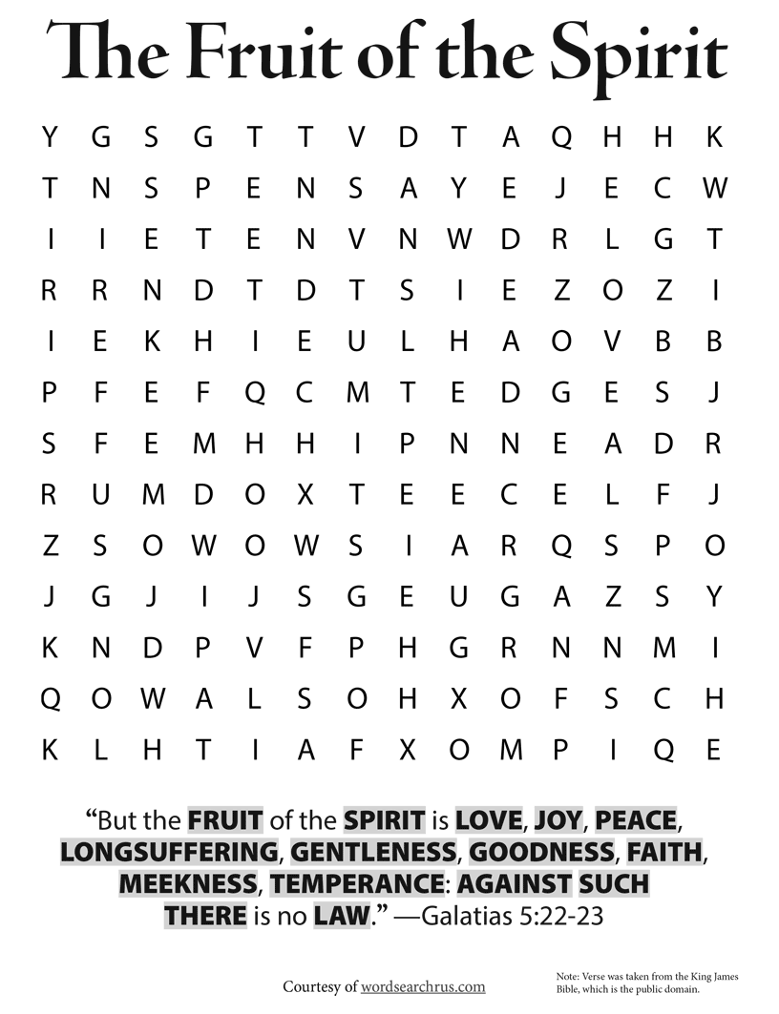

*Needed: Special music, help with cleaning, Trinity kids.

Now is the time. God wants to do something new in your life!
Will you let Him?
Will you accept this new thing that He has planned for you?
I know my answer. I will gladly accept this new thing. I will follow wherever He leads me. I will hold tight to His promises when things get tough. And, when the time is right, just like the blooming spring flowers, I will spring forth.
Remember ye not the former things, neither consider the things of old. Behold, I will do a new thing; now it shall spring forth; shall ye not know it? I will even make a way in the wilderness, and rivers in the desert.
Is. 43:18-19

Phone: 913-262-2289
Email: pastor.trinity.ks@att.net
Website: https://www.trinitybaptistmerriam.org/

Wi-Fi Password: Psalm122:1

