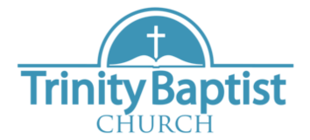
Welcome!
November 3rd, 2024
Pastor Ed Thompson
Our Services:
Sunday: 9:45, 10:45, 5:00
Wednesday: 7:00
Announcements:
*Trinity Kids: Nov. -Eastons
Dec.?
*Special Music is much needed & enjoyed! Please see Michael.
*Help needed: decorating, cleaning, outside sign, and Trinity Kids.



Do we want revival?
The point of revival is for the word of God to shine a light on what has dwelt in darkness (Isaiah 9:2)

When God comes, His presence is severe because He demands that we destroy whatever idol sits on the throne of our heart; and His presence is gentle for the same reason. If you want to know what to expect when revival comes, identify the gods that have taken the place of the Holy One.

Wilt thou not revive us again: that thy people may rejoice in thee? Ps. 85:6




Phone: 913-262-2289
Email: pastor.trinity.ks@att.net
Website: https://www.trinitybaptistmerriam.org/
Wi-Fi Password: Psalm122:1

