

Welcome!
September 8th, 2024
Our Services:
Sunday: 9:45, 10:45, 5:00

Wednesday: 7:00

Announcements:
*Trinity Kids: Sept.– Judy
*Trinity Kids – No one is signed up for October, November, and December!
*Baptismal – Today!
*Ladies Fellowship – This coming Saturday, 10 am in Fellowship Hall, bring fall finger foods to share! See Emily for information!

*Senior Meeting – Friday, Sept. 27th @ 6 pm in the church fellowship hall. See David or Sarah for information.
*Fellowship Sunday – Sept. 29th, Following morning service, bring a Mexican dish to share!
*There are a few things that need to be done around the church, please see David or the pastor.

*We need to get more door hangers completed. If you can help, please see pastor.

Luke 17:26 And as it was in the days of Noe, so shall it be also in the days of the Son of man.
“When Noah drove that last nail into the ark, he may have had nothing left. When he
came out of the ark, he had inherited the Earth. He went in a minority and came out a majority.”

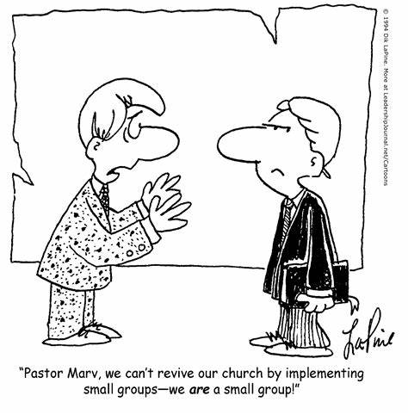


Phone: 913-262-2289
Email: pastor.trinity.ks@att.net
Website: https://www.trinitybaptistmerriam.org/

Wi-Fi Password: Psalm122:1

