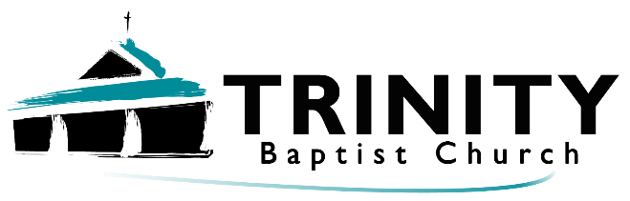

Welcome!
July 14th, 2024
Our Services:
Sunday: 9:45, 10:45, 5:00

Wednesday: 7:00
Announcements:

*Trinity Kids: July 7th & 21st - Eastons
*Sunday Night Bible studies:
Ladies – It’s all under control.
Men – Men of Valor

*Church Camp – July 29th-July 2nd, Silver State, Colorado, Camp counselors – Pastor & Emily, see pastor for more information.

*Passing out flyers – Let pastor know when (even a weekday works!) Possibly doing a weekly mailing.
*Help needed: Cleaning, teaching, maintenance, hanging up tract board, painting church kitchen, visiting, and much more! How can you serve?


Remain Faithful to God in a Faithless World

The Bible is Our Guide.

The Bible Equips Us.

Stick to Truth.


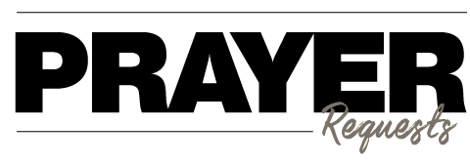
- Our Church
- Our Pastor
- Our Outreach
- Our Faithfulness
- Our Service
- The Lost
- Our Sick
- Our requests

The largest jellyfish in the world is the lion’s mane jellyfish. It is named for the hundreds of long tentacles that make up its “mane.” These tentacles can be over 100 feet long—that's longer than a blue whale!

Phone: 913-262-2289
Email: pastor.trinity.ks@att.net
Website: https://www.trinitybaptistmerriam.org/
Wi-Fi Password: Psalm122:1

