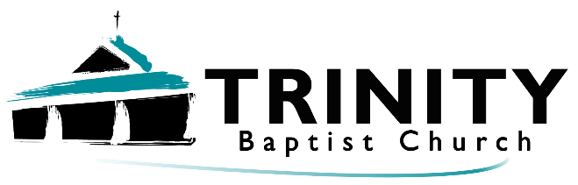

Welcome!
June 9th, 2024
Our Services:
Sunday: 9:45, 10:45, 5:00
Wednesday: 7:00

Announcements:
*Happy belated Anniversary to Cecil & Jan!

*Happy birthday to:
11th – Judy
13th – Sydney
15th - Jess
*Trinity Kids: June 16th & 30th – Michael & Emily
*Sunday Night Bible studies:
Ladies – It’s all under control.
Men – Men of Valor
*Father’s Day – June 16th

*Fellowship – Watermelon & snacks – 5:00 – June 23rd.
*Passing out flyers – Let pastor know when (even a weekday works!)
****************************************************************
What should be the believer’s duty in response to salvation?
The Christian must be mentally prepared to serve.
The Christian must be self-controlled and sober in daily life.
The Christian must be hopeful and expectant of future grace.
The Christian must be an obedient child.
****************************************************
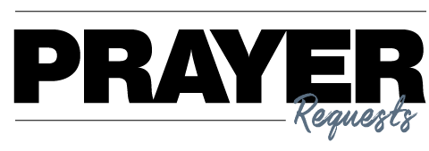

- Our Church
- Our Pastor
- Our Outreach
- Our Faithfulness
- Our Service
- The Lost
***************************************

Weren't Dinosaurs Too Big for The Ark?
Not at all. The average size of a dinosaur is about the size of a large sheep or bison. God probably sent young, small dinosaurs, NOT old, big ones.



Phone: 913-262-2289
Email: pastor.trinity.ks@att.net
Website: https://www.trinitybaptistmerriam.org/
Wi-Fi Password: Psalm122:1

