


Welcome!
June 23rd, 2024
Our Services:
Sunday: 9:45, 10:45, 5:00
Wednesday: 7:00

Announcements:
*Trinity Kids: June 30th – Michael & Emily
July 7th & 21st - Eastons
*Sunday Night Bible studies:
Ladies – It’s all under control.
Men – Men of Valor
*Fellowship TONIGHT! – Watermelon & snacks – 5:00 – June 23rd.

*Church Camp – July 29th-July 2nd, Silver State, Colorado, Camp counselors – Pastor & Emily, see pastor for more information.
*Passing out flyers – Let pastor know when (even a weekday works!) Possibly doing a weekly mailing.

Are you

No one should ever take a break from God, his glory, and the mission he gives each of us. When we break for the summer — from Sunday school, small group, community outreach, or wherever you serve in your local church — God still calls us to seek him with all our heart, soul, mind, and strength.

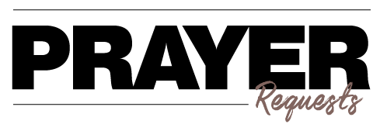
- Our Church
- Our Pastor
- Our Outreach
- Our Faithfulness
- Our Service
- The Lost
- Our Sick
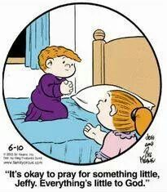


Phone: 913-262-2289
Email: pastor.trinity.ks@att.net
Website: https://www.trinitybaptistmerriam.org/
Wi-Fi Password: Psalm122:1

